

**School of Computer Science Engineering and Information Systems (SCORE)**

**Winter Semester 2023-2024**

**BITE307P-SOFTWARE ENGINEERING LAB**

Software Requirement Specification Document

|  |  |
| --- | --- |
| Document ID | SOFTWARE REQUIREMENT SPECIFICATION-v0.1 |
| Version Number | 1.0 |
| Issue Date | Jan 22, 2024 |
| Classification | Public |

PREPARED BY: PRASHANT | 21BIT0524

Copyright Notice

© Transcriptor & Summarizer, (2024)

All Rights Reserved

The information contained in this document is the property of Transcriptor & Summarizer. No part of this document may be reproduced, stored in a retrieval system, or transmitted in any form, or by any means; mechanical, photocopying, recording, or otherwise, without the prior written consent of TRANSCRIPTOR & SUMMARIZER. Under the law, copying includes translating into another language or format. Legal action will be taken against any infringement.

The information contained in this document is subject to change without notice and does not carry any contractual obligation for TRANSCRIPTOR & SUMMARIZER. TRANSCRIPTOR & SUMMARIZER reserves the right to make changes to any products or services described in this document at any time without notice. TRANSCRIPTOR & SUMMARIZER shall not be held responsible for the direct or indirect consequences of the use of the information contained in this document.

Revision History

|  |  |  |  |
| --- | --- | --- | --- |
| **Date** | **Version** | **Description** | **Author** |
| 18/01/2024 | 1.0 | Draft Version with basic functionality | Prashant |
| 19/01/2024 | 1.1 | Added dark mode | Prashant |
| 20/01/2024 | 1.2 | Added summarizer | Prashant |
| 22/01/2024 | 1.3 | Integrated dictionary | Prashant |
| 23/01/2024 | 1.4 | Rectified bugs and finalized the software | Prashant |

|  |  |  |
| --- | --- | --- |
| **Reviewed By (Customer)** | **Signature** | **Date** |
| Chirag |  | 23/01/2024 |
| Piyush |  | 24/01/2024 |

The reviewer signoff shall signify the recommendation for acceptance of this document.

Table of Contents

1 Introduction 6

1.1 Purpose 6

1.2 Document Conventions 6

1.3 Intended Audience and Reading Suggestions 6

1.4 Project Scope 6

1.5 References 6

1.6 Acronyms and Abbreviations 7

2 Overall Description 7

2.1 Product Perspective 7

2.2 Product Features 8

2.3 User Classes and Characteristics 8

2.4 Operating Environment 9

2.5 Design and Implementation Constraints 9

2.6 User Documentation 9

2.7 Assumptions and Dependencies 9

3 System Features 9

4 External Interface Requirements 11

4.1 User Interfaces 11

4.2 Hardware Interfaces 13

4.3 Software Interfaces 14

4.4 Communications Interfaces 14

5 Other Nonfunctional Requirements 15

5.1 Performance Requirements 15

5.2 Safety Requirements 15

5.3 Security Requirements 16

5.4 Software Quality Attributes 16

6 Other Requirements 16

Appendix A: Glossary 15

Appendix B: Analysis Models 16

Appendix C: Issues List 16

Introduction

# Purpose

# The purpose of this document is to define the functional and non-functional requirements for the development of an audio conversion and text manipulation application.

## This application is designed to allow users to convert audio files to text, summarize text content, change the theme between dark and light modes, and find meanings of words within the text.

# Document Conventions

* Bold Text: Denotes system features and functionalities.
* Moonspace Font: Represents code snippets or technical terms.
* Italic Text: Highlights important notes or considerations.

# Intended Audience and Reading Suggestions

**Intended Audience:**

* Developers
* Testers
* Company employees
* Differently abled social media users
* Project Managers
* Stakeholders involved in the application development

**Reading Suggestions:**

* Start with the "Purpose" section for an overview of the document.
* Developers should focus on the "Project Scope" and "Functional Requirements" sections.
* Testers should pay attention to the "Testing Requirements" section.
* Project Managers should review the entire document for a comprehensive understanding of project goals.

# Project Scope

**Software Overview:**

The software is a versatile audio conversion and text manipulation application, allowing users to convert audio to text, summarize content, change themes, and find word meanings.

**Purpose:**

Enable seamless interaction with audio and text, offering personalized experiences and enhancing language comprehension.

**Benefits:**

* Enhanced Accessibility
* Efficient Information Processing
* Personalized User Experience
* Language Understanding

**Objectives:**

* Accurate audio-to-text conversion
* Advanced text summarization
* Intuitive UI with theme customization
* Reliable word meanings lookup

**Goals:**

* High accuracy in audio-to-text conversion
* Efficient text summarization algorithms
* User-friendly interface with responsive theme change
* Reliable and swift word meanings lookup

**Business Strategies:**

* User-Centric Approach
* Continuous Improvement
* Collaboration and Partnerships
* Scalability

# References

[IEEE Std 830-1998](https://standards.ieee.org/standard/830-1998.html): IEEE Recommended Practice for Software Requirements Specifications.

# Acronyms and Abbreviations

The following acronyms and abbreviation will apply to this document.

* SRS: Software Requirements Specification
* UI: User Interface
* API: Application Programming Interface
* QA: Quality Assurance

# Overall Description

## Product Perspective

The software being specified in this SRS is a standalone application designed to facilitate audio conversion and text manipulation tasks. It is a self-contained product aimed at providing users with comprehensive tools for converting audio files to text, summarizing textual content, changing themes, and finding word meanings. The software operates independently on the user's local system and does not rely on external systems or dependencies.

## Product Features

The major features of the software include:

* Audio-to-text conversion functionality.
* Text summarization capability.
* Theme customization (dark/light themes).
* Word meanings lookup within the text.
* Text to speech: reads out the transcribed text.

These features are seamlessly integrated into the application to provide users with a cohesive experience in managing audio and textual data.

## User Classes and Characteristics

**User Classes:**

1. **General Users:**
   * These users have basic technical proficiency and use the software for everyday tasks for audio to text conversion and saving or copying it.
2. **Advanced Users:**
   * Users with higher technical expertise who may utilize more advanced features of the application such as the summarize option and text to speech feature.

**User Characteristics:**

* **Frequency of Use:** Users may range from occasional to frequent users depending on their needs.
* **Technical Expertise:** General users may have limited technical knowledge, while advanced users possess more in-depth understanding.
* **Educational Level:** Varied educational backgrounds, with users ranging from students to professionals.
* **Experience:** Users may have diverse levels of experience in working with similar software applications.

## Operating Environment

The software can run on any windows platform with windows 8.1 and above, requires at least 100mb of disk space. It is recommended to stay connected to the internet to get the optimum functionality such as word meanings lookup.

## Design and Implementation Constraints

* The software must adhere to Windows platform compatibility.
* It should operate within the constraints of the available hardware resources.
* The application should follow industry-standard security protocols for data privacy and protection.
* It may utilize external APIs and services for certain functionalities.
* Design and implementation should align with established coding standards and conventions.

## User Documentation

The user documentation components to be delivered along with the software include:

* User manual providing instructions on software usage.
* Online help resources accessible within the application interface.
* Tutorials or guides for specific features and functionalities.
* The documentation will be provided in digital formats, possibly in PDF or HTML format, adhering to standard documentation delivery standards.

## Assumptions and Dependencies

* The software assumes a stable internet connection for optimal functionality, especially for word meanings and summarization.
* Dependencies include third-party libraries and APIs for audio processing, text summarization, and word meanings retrieval.
* The development environment assumes access to development tools compatible with Windows platform development.
* It assumes adherence to relevant software development standards and guidelines during the development process.

System Features

# Audio-to-Text Conversion:

1. **Mode of Operation:** On clicking the ‘Choose Audio File’ button, users, irrespective of their user class, can upload audio files in various formats (.wav, .mp3, .aac).
   * **Functional Hierarchy:**
     + User initiates the audio file selection process.
     + Application utilizes libraries such as speech_recognition to convert audio content to textual representation.

# Text Summarization:

1. **Mode of Operation:** Users can generate concise summaries of provided text content by clicking the 'Summarize' button.
   * **User Class:** Regular, Power, and Occasional Users
   * **Functional Hierarchy:**
     + User triggers the summarization process by clicking the button.
     + The application utilizes summarization algorithms to produce concise summaries.

# Theme Change (Dark/Light):

1. **Mode of Operation:** Users can toggle between dark and light themes for a personalized visual experience using the button with the moon’s icon.
   * **User Class:** Regular, Power, and Occasional Users
   * **Functional Hierarchy:**
     + User triggers the theme change process by clicking the theme toggle button.
     + Application updates the visual theme based on user preference.

# Word Meanings Lookup:

1. **Mode of Operation:** Users can find meanings of specific words within the text by selecting that word and clicking the 'Means' button.
   * **User Class:** Regular, Power, and Occasional Users
   * **Functional Hierarchy:**
     + User selects a word within the text.
     + Application retrieves the meaning of the selected word using external resources such as dictionaries.

# Text to Speech:

1. **Mode of Operation:** Users can listen to the transcribed text with a single click on the 'Read' button.
   * **User Class:** Regular, Power, and Occasional Users
   * **Functional Hierarchy:**
     + User triggers the text-to-speech functionality by clicking the 'Read' button.
     + Application utilizes text-to-speech engines to convert textual content into speech.

# Save the Text as Text File:

1. **Mode of Operation:** Users can save the file as a text document in their system using the 'Save' button at the bottom.
   * **User Class:** Regular, Power, and Occasional Users
   * **Functional Hierarchy:**
     + User initiates the save process by clicking the 'Save' button.
     + Application prompts user for file location and saves the text document accordingly.

External Interface Requirements

# User Interfaces

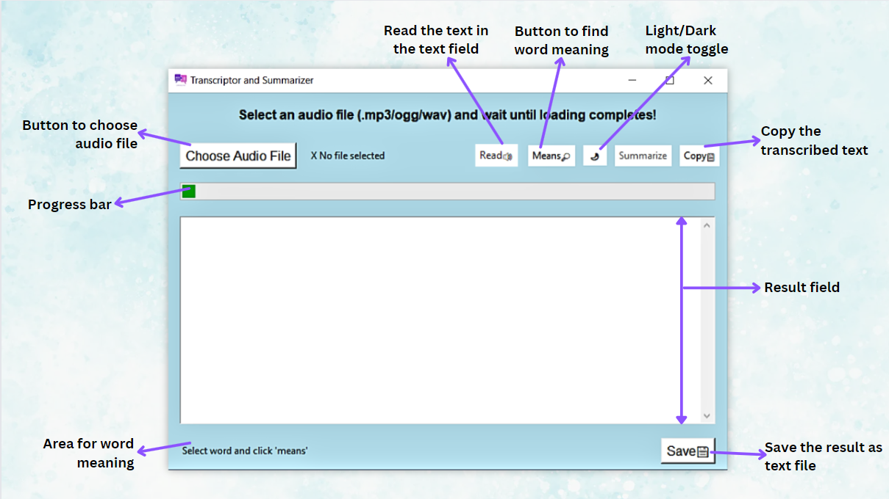

*Overview of the buttons and functions*

1. **Audio-to-Text Conversion Module:**
   * Interface Characteristics: Simple file selection and loading with real-time recognition feedback.
   * GUI Standards: Follow standard file selection dialogs for user convenience.
   * Screen Layout Constraints: Display recognition progress and estimated time.
   * Standard Buttons and Functions: Buttons for file selection, conversion initiation, copying, summarizing, and saving. Progress bar for visual feedback.
   * Keyboard Shortcuts: Consider implementing common shortcuts for actions like copying and saving.
2. **Text Summarization Module:**
   * Interface Characteristics: A button triggering summarization, indicating whether original or summarized text is displayed.
   * GUI Standards: Follow a clear and consistent button design for summarization.
   * Screen Layout Constraints: Display clear indicators for the original and summarized text.
   * Standard Buttons and Functions: Buttons for summarization and toggling between original and summarized text.

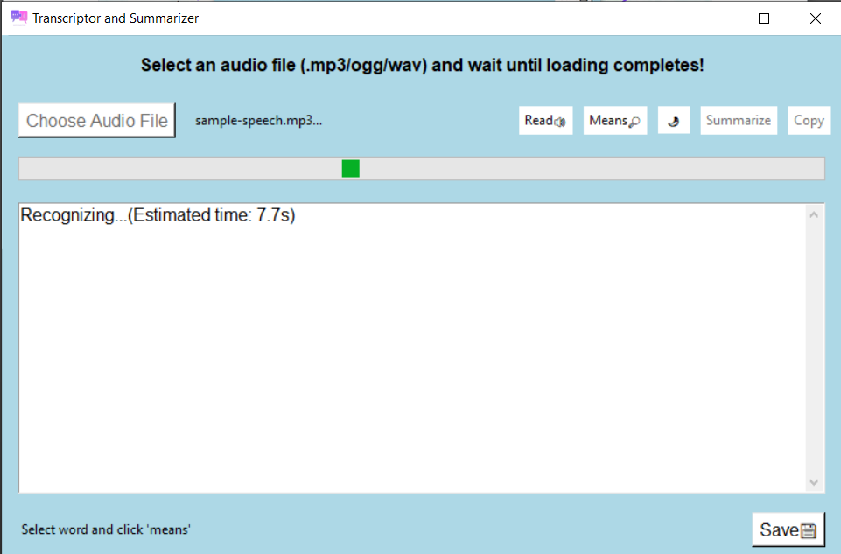

* While summarizing, an estimated time will be shown for allowing users to manage their time accordingly.

1. **Theme Customization Module:**
   * Interface Characteristics: A button for toggling between dark and light modes.
   * GUI Standards: Follow standard design conventions for mode toggling buttons.
   * Screen Layout Constraints: Ensure a visually appealing transition between modes.
   * Standard Buttons and Functions: Button for toggling between dark and light modes.

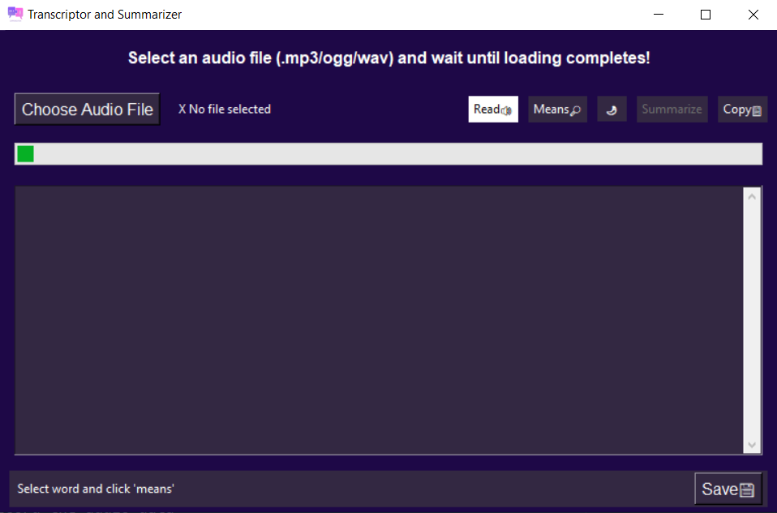

*Dark theme*

1. **Word Meanings Lookup Module:**
   * Interface Characteristics: A button triggering word meanings lookup on the selected text.
   * GUI Standards: Use standard search icons or buttons for consistency.
   * Screen Layout Constraints: Display the result in a designated area.
   * Standard Buttons and Functions: Button for word meanings lookup.

# Hardware Interfaces

**Supported Device Types:**

* The software supports devices with audio input capabilities, including speaker for the audio to play when read button is clicked.

**Data and Control Interactions:**

* Interaction involves reading audio files, processing audio data, and presenting results through the graphical user interface.

**Communication Protocols:**

* The software interfaces with audio input/output hardware using standard protocols for audio data transfer.

# Software Interfaces

**External Software Components:**

1. **Transformers Library:**
   * Version: 4.33.2
   * Purpose: Utilized for natural language processing tasks, including text summarization.
   * Functions used: T5Tokenizer and T5ForConditionalGeneration
2. **Speech Recognition Library:**
   * Version: 3.10.0
   * Purpose: Utilized for recognizing speech in audio files.
3. **PyDictionary Library:**
   * Version: 2.0.1
   * Purpose: Utilized for looking up word meanings.
4. **Pydub:**
   * For converting any audio format into desired format.

**Data and Message Exchange:**

* Data Items or Messages: Audio files, transcribed text, summarization results, and word meanings.
* Services: Speech recognition, text summarization, theme customization, and word meanings lookup.

# Communications Interfaces

**Communication Protocols:**

* Utilizes standard Python libraries and third-party libraries (e.g., transformers, speech recognition) for communication.

**Security and Encryption:**

* No specific security or encryption issues mentioned; however, data transfer and communication follows standard secure practices.

**Data Transfer Rates:**

* Data transfer rates are dependent on the audio file size and processing capabilities.

**Synchronization Mechanisms:**

* Synchronization is primarily achieved through user interactions with the graphical user interface, with real-time feedback during audio processing.

Other Nonfunctional Requirements

# Performance Requirements:

* **Audio-to-Text Conversion:**
  + The conversion process should be completed within a reasonable time frame, typically not exceeding 30 seconds for audio files up to 5 minutes in duration.
* **Text Summarization:**
  + Summarization of text should be performed swiftly, with processing times not exceeding 5 seconds for texts up to 1000 words.
* **Theme Change (Dark/Light):**
  + Theme change operations should be instantaneous, providing a seamless transition between dark and light themes.
* **Word Meanings Lookup:**
  + Word meanings lookup should be responsive, with results displayed within 3 seconds of selecting a word.
* **Text to Speech:**
  + Text-to-speech conversion should occur without noticeable delays, enabling smooth playback of transcribed text.

Safety Requirements:

* **Data Integrity:**
  + The software should ensure data integrity during audio-to-text conversion and text manipulation processes to prevent loss or corruption of user data.
* **User Privacy:**
  + The application should adhere to privacy regulations and standards, ensuring that user data is protected and not shared with unauthorized entities.

Security Requirements:

* **User Authentication:**
  + The application may implement user authentication mechanisms to ensure that only authorized users can access sensitive functionalities.
* **Data Encryption:**
  + User data should be encrypted during transmission and storage to prevent unauthorized access and ensure data confidentiality.

Software Quality Attributes:

* **Reliability:**
  + The software should operate consistently and reliably under normal and peak load conditions, minimizing the risk of crashes or unexpected behavior.
* **Usability:**
  + The user interface should be intuitive and user-friendly, allowing users of all technical levels to navigate and utilize the application efficiently.
* **Maintainability:**
  + The software should be designed and implemented in a modular and maintainable manner, allowing for easy updates, bug fixes, and enhancements.

# Appendix A: Glossary

* **SRS:** Software Requirements Specification
* **API:** Application Programming Interface
* **GUI:** Graphical User Interface

# Appendix B: Analysis Models

* Data Flow Diagrams depicting the flow of data within the system.
* Class Diagrams illustrating the relationships between system classes and objects.

# Appendix C: Issues List

* TBD: To Be Determined
* Pending Decisions: Issues awaiting resolution from stakeholders or project team members.
* Conflicts: Issues requiring resolution due to conflicting requirements or decisions.